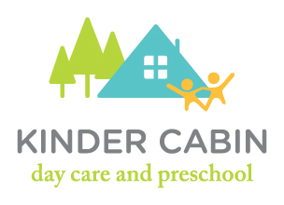

Contract Agreement

Please sign the attached form to acknowledge that you have read these policies, that you understand them, and that you agree to abide by them.

KINDER CABIN LLC
Contract Agreement

I, ________________________________ agree to abide by the policies and procedures described in KINDER CABIN PARENT’S HANDBOOK. I have thoroughly read the contract and understand it. I also understand that failing to comply with this contract may result in the discontinuation of care of my child .If you have any questions at all, please do not hesitate to call or email.

Signed: _________________________________ Date: _________

